Walk 33 Around Twyn-Y-Gaer
Last walked in August 2016

Description. An 9 km (5.5 mile) walk. This is a strenuous walk but has much historical interest. An Iron Age fort caps the summit of Twyn-y-Gaer with panoramic views over three valleys.
Start. Walkers’ Car Park just north of the Queen’s Head Inn. Explorer Map OL13. Grid 311222
Directions from Tesco’s Roundabout (Turn milometer to zero). Take the A465 Abergavenny road and at 16.6m TR signposted for Llanthony. A little further on TR again, signposted Llanthony 6. Carry on along the Llanthony road for another 1½ mile to The Queen’s Head Inn, the total distance being 18.2 miles. The Walkers Car Park is on the opposite side of the road. A daily £2 charge is requested and should be paid at the pub.

1. The Queens Head. Ascend the steep tarmac road, which leaves the valley road at the entrance to the car park. A steady climb leads thru the woods up the ridge of Twyn-y-Gaer. Eventually the tarmac ends and the ascent continues along a well defined dirt track, a promenade, to reach a metal gate.

2. Open Land. Pass thru a metal gate to enter the open land. Immediately TL and climb up a broad grassy track thru the bracken, following a fence is on your L. It veers to the L just below the highest part of the hill and then veers to the R to attack the summit from the east. A cairn marks the top at 427m. The summit plateau is a delightful grassy promenade, studded with gorse bushes. It’s easy to see why the ancient Britons chose this site, perched on a hilltop overlooking three valleys. The ditches and ramparts are still discernable. The fort is oval in shape and covers an area of over 4 acres. It consists of three sections, surrounded by a double embankment. From the top you can see the sites of two neighbouring forts. Eastward lies Trewyn at the southern end of the Hatterrall ridge, while Crug Hywel crowns the Table Mountain above Crickhowell. At the top carry straight on past the cairn to the end of the summit plateau. A deep defensive, ditch marks the boundary of the fort. It is easiest to cross this at the L hand end, then picking up a clear grassy path sloping downhill to the R. After a short steep section, there's a graceful descent thru the bracken to the wide saddle of the ridge. From here you can see the ridge ahead is quite narrow and the valleys either side are not far apart. But they drain in completely different directions. To the L, the Grwyne Fawr’s water supply the Usk, eventually passing under Newport's transporter bridge to join the Bristol Channel. To the L the Honddu unites with the Monnow a few miles north, and the water then flows to the Wye and on to the Severn at Chepstow. At the bottom, on the R hand side, you come to a wall and fence and meet a track running alongside it. Bear L to join this track and continue along it. In about 500 yards you pass a house set back on the R. About 300 yards further you reach a junction of tracks with a wall now on both sides.

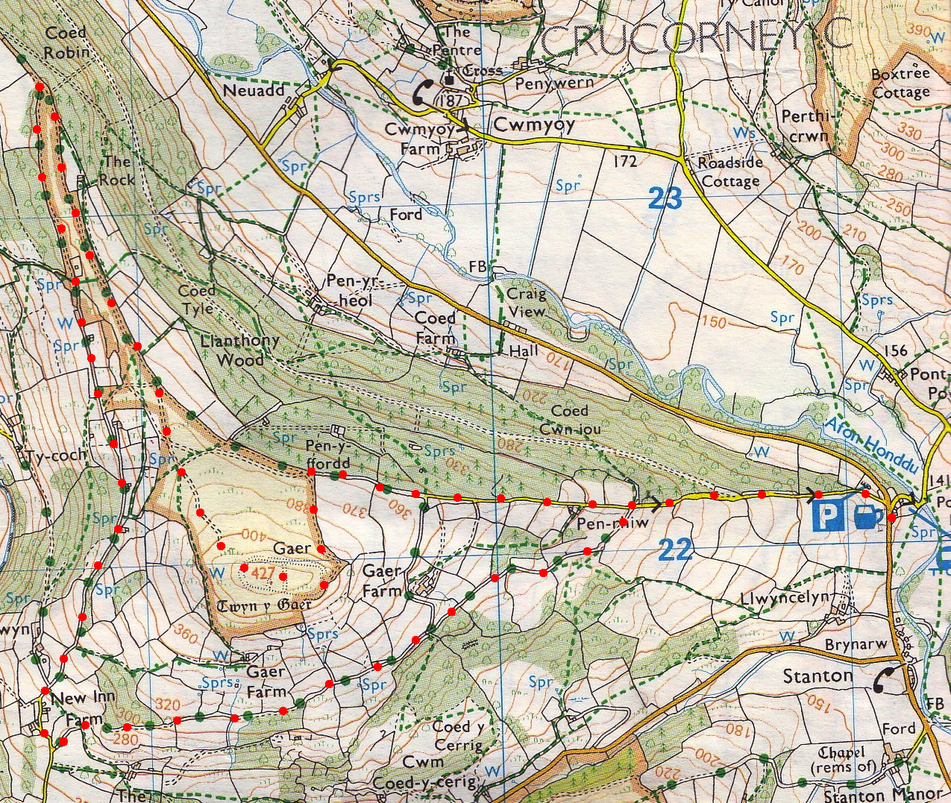
3. Sharp L. Turn immediately to the L here and continue along another track, keeping to a wall on your R. Follow this track just above a wall and a wood just below the crest of the ridge. Pass a ruined building on your R as you proceed along an enclosed track. Continue on to reach a metal gate. Pass thru the metal gate and continue along an enclosed walled track, which descends gently with views to the R, across the Grwyne Fawr and over to the Sugar Loaf. Towards the bottom the track is joined by a concrete lane coming in from the L. Continue down the roughly surfaced road as it approaches some farm buildings. Follow the road past the whitewashed cottages.

4. Sharp L. Not far past the cottages, and just before a tarmac lane on your L, and next to a telegraph pole, TL to follow a muddy track and then go thru a metal gate. Avoid side turnings to a quarry (R) and ascend steadily on the track that bends right though oak, holly and hazel trees, fence is on your L. As the road levels out enjoy south facing views over Cwm Coed-y-Cerrig and the National Nature Reserve, managed by the Countryside Council for Wales. Tbe boggy area in the bottom of the valley includes many alder trees and offers a good habitat for frogs. Higher up the hillside, towards the course of our walk, drier terrain supports mixed woodland including oak, ash, beech and hazel. The secretive Dormouse can be found here, so look out! On the highest section of the route you use the slight diversion that goes around the house. A gate leads to a walled lane, which descends thru the trees and joins the road. TR to walk down the road to the car park.
1
3
2
4

